Email Sender

you can send Email to anybody through this application.

I have used mail.jar library for this.

Screenshot:

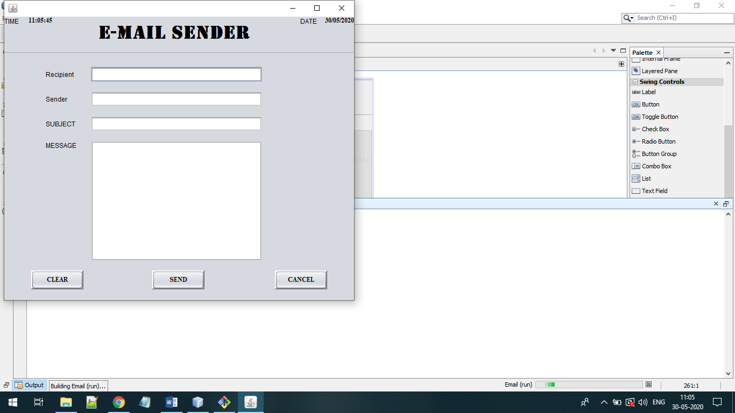

Clear button will clear the content in the subject, message and recipient textbox.

Cancel button is used to close the frame.

Send button will send email after entering RECIPIENT email address and subject and message.

The email should be in proper format i.e., [abc@any.com](mailto:abc@any.com).